# **Creating Gantt Project for Facebook Profile Implementation**

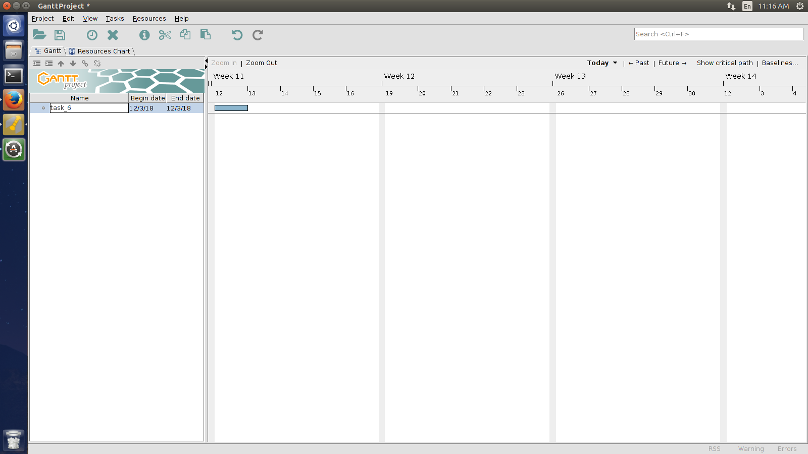

**Setting a new Task**

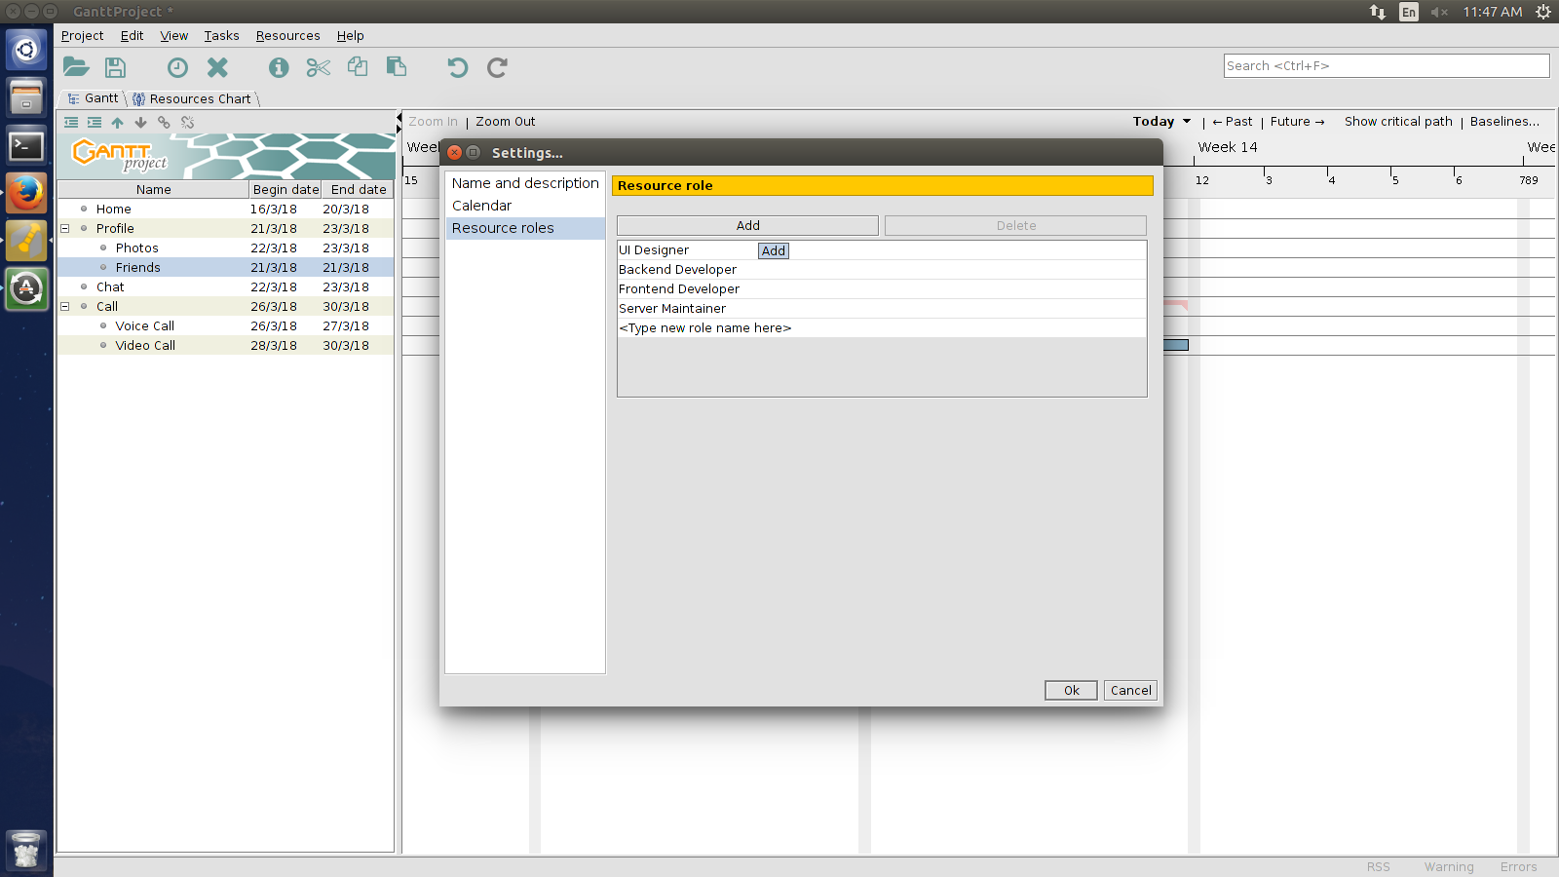

**Adding Resource Roles**

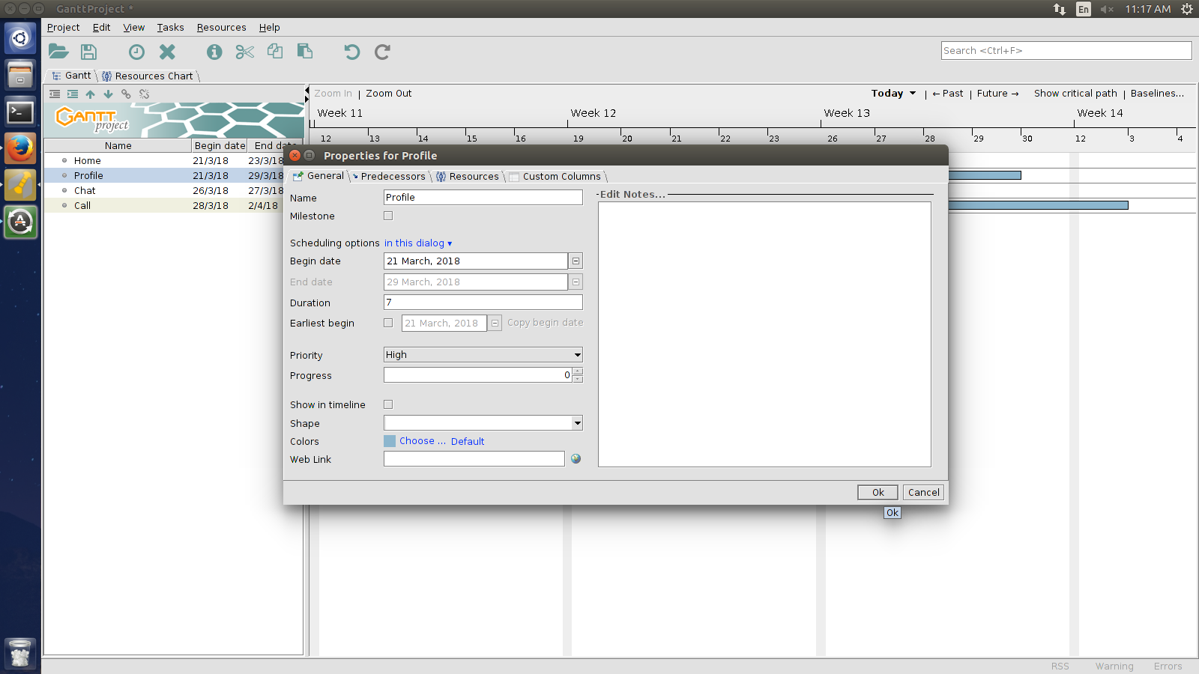

**Setting Profile Properties**

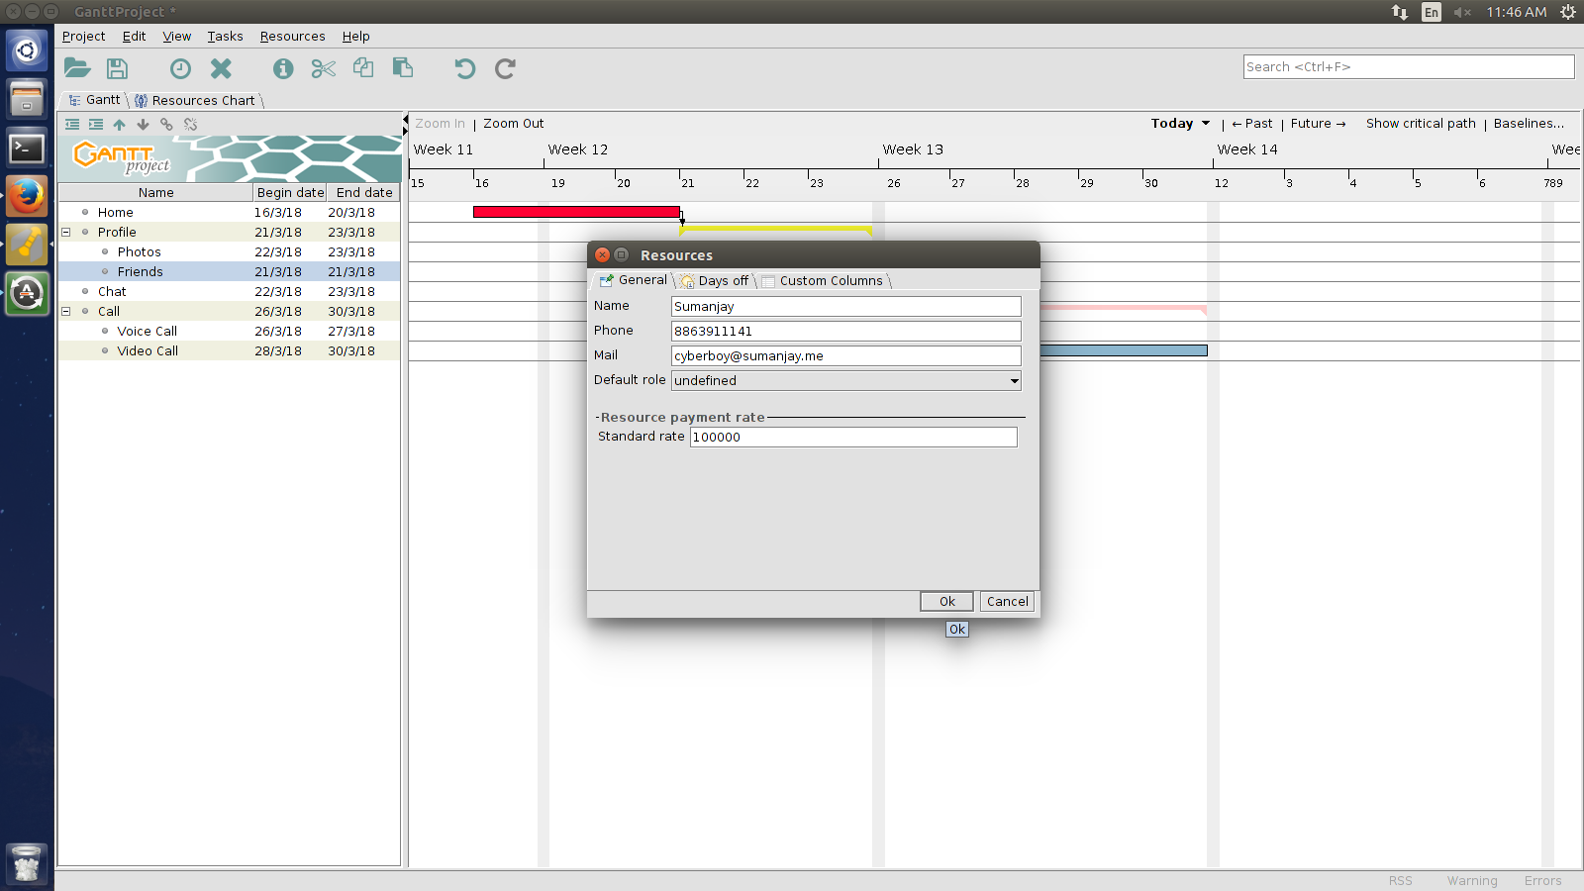

**Adding Resource Details**

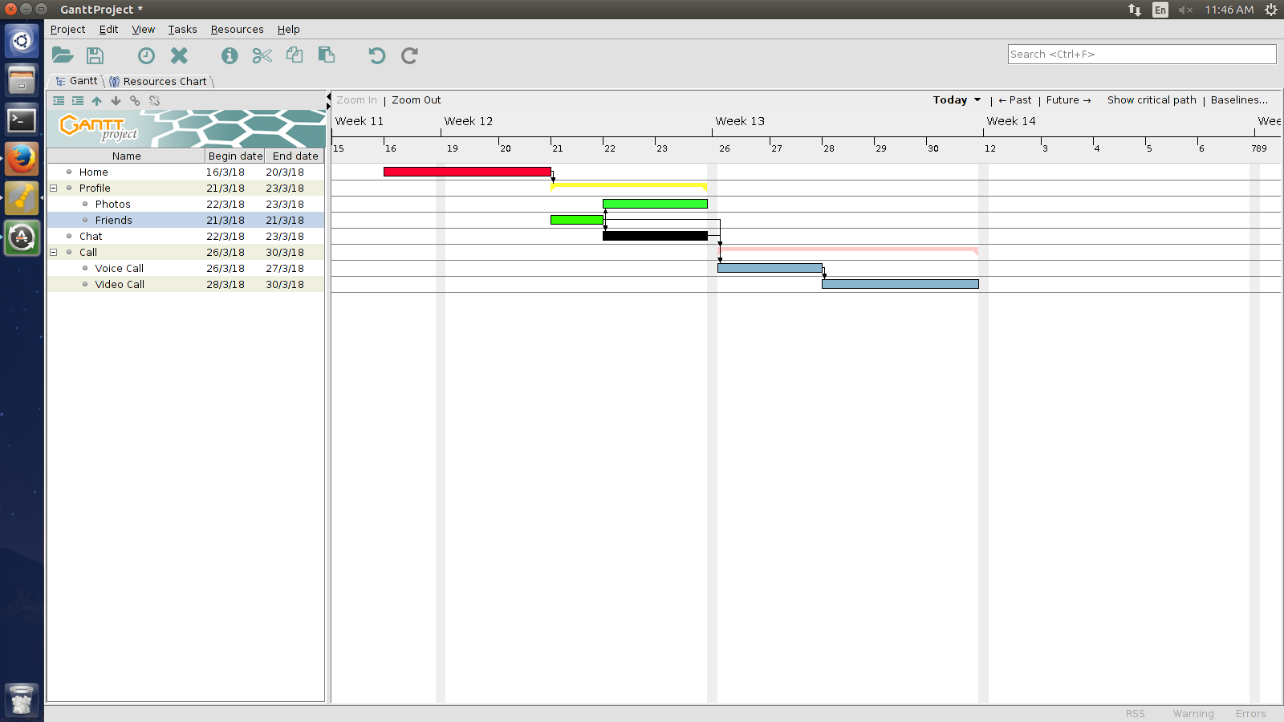

**Final Gantt Chart for the Project**